**Name: ROBBIN K S**

**DEPARTMENT: COMPUTER SCIENCE AND ENGINEERING**

**COURSE DETAIL: DIGITAL MARKETING**

**COLLEGE: DHANALAKSHMI SRINIVASAN INSTITUTE OF TECHNOLOGY**

**NM ID: C6B749CA8AB9CD0A9AF4207874D611A2**

**ZONE: 12**

**ASSIGNMENT 1:**

Create a blog or website using Blogspot and WordPress. Customize

The theme design and post new article with 500 words.

<https://bikersclub66.blogspot.com/2023/08/bikers-club.html>

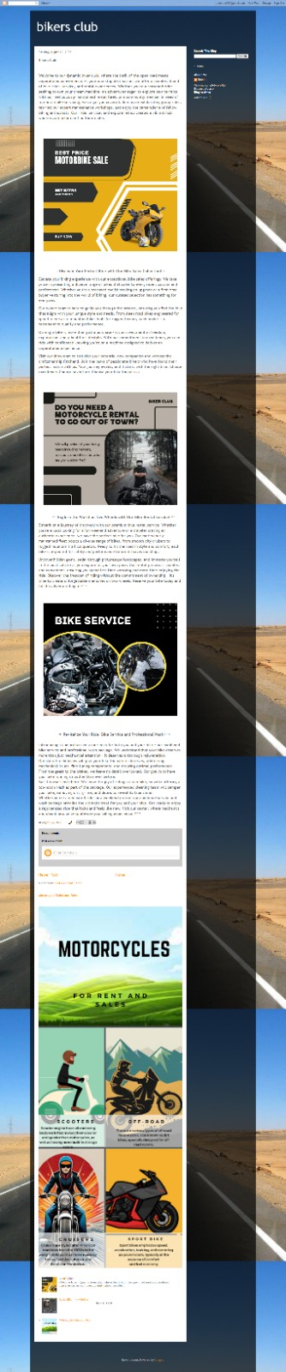

**ASSIGNMENT 2:**

Create a new Facebook business Page and Post one social media poster for your brand.

<https://www.facebook.com/profile.php?id=61550338182422>

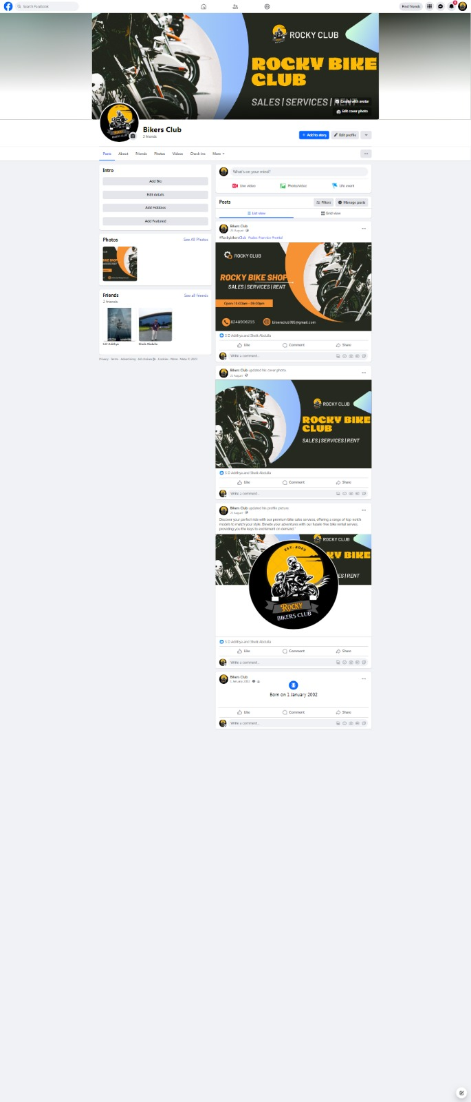

**ASSIGNMENT 3:**

Create and design a social media advertisement poster using Canva.

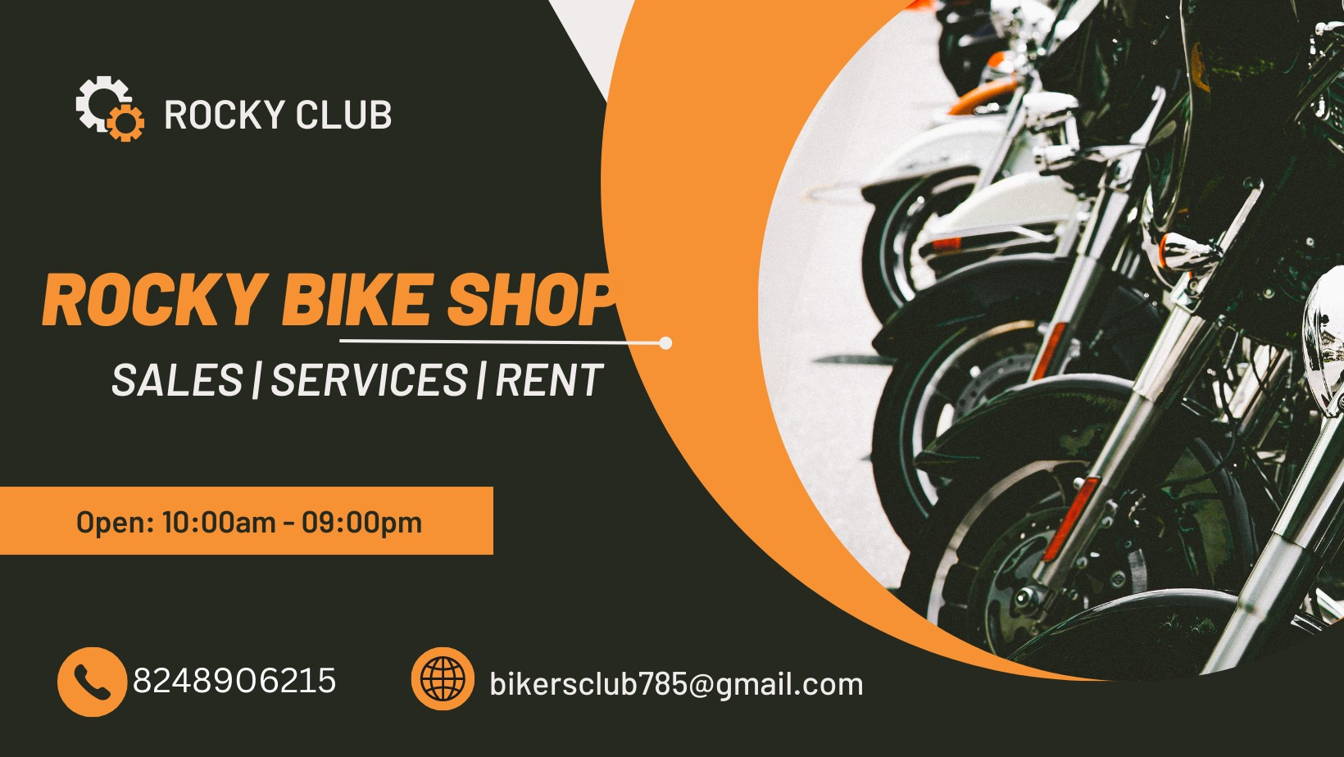

**ASSIGNMENT 4:**

4.Create email newsletter design using MailChimp or Canva tool.

